Project Folder Created

Here is the screenshot documenting the project folder creation and virtual environment activation:
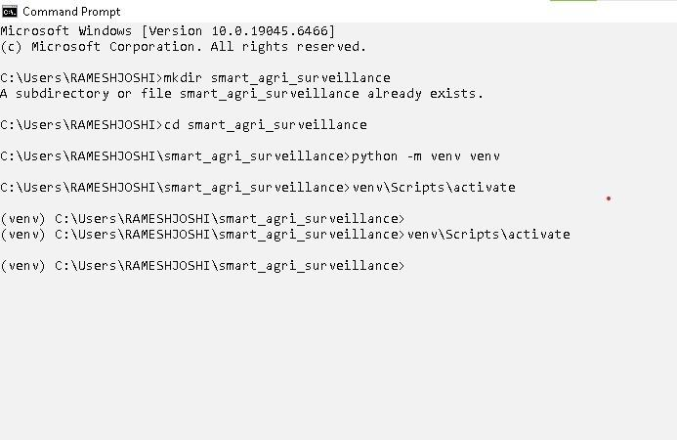

Step Summary:
- Directory Check: Attempted to create smart_agri_surveillance (folder already existed).
- Navigation: Navigated into the smart_agri_surveillance directory.
- Environment Setup: Created a Python virtual environment named venv.
- Activation: Successfully activated the virtual environment (venv prefix visible in the prompt).

Virtual Environment and Required Dependencies Created
torch
This document verifies the initialization of the virtual environment, implementation of the directory structure, package dependencies extraction, and validation checks for core modules including
and .
ultralytics (YOLO)

Package Download and Installation Process

The following sequence captures the automated installation logs for key scientific and computer vision
pandas
matplotlib
opencv-python
ultralytics

packages (including numpy ,
,
,
, ,

, and ):
jupyterlab
torch
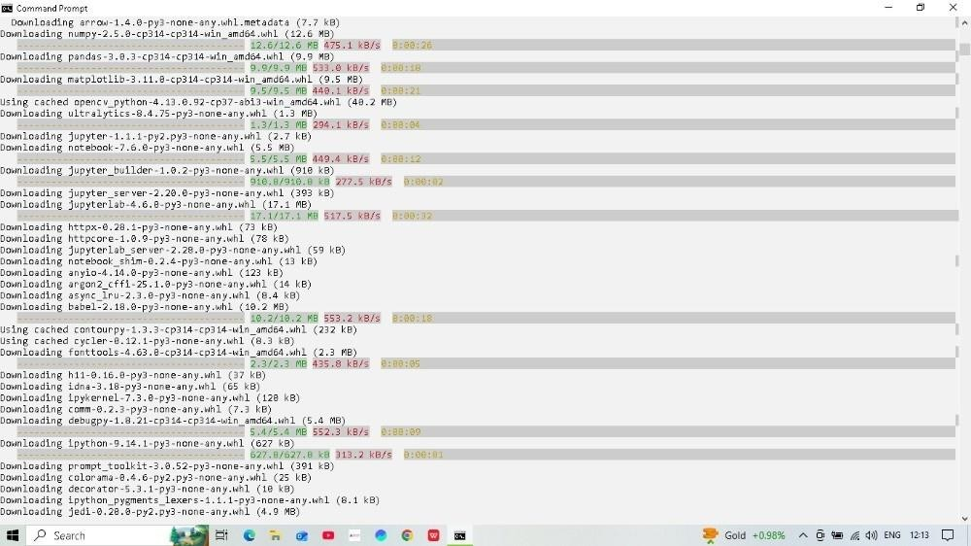

Figure 1.1: Dependency streaming initialization (Pandas, Matplotlib, Ultralytics packages)

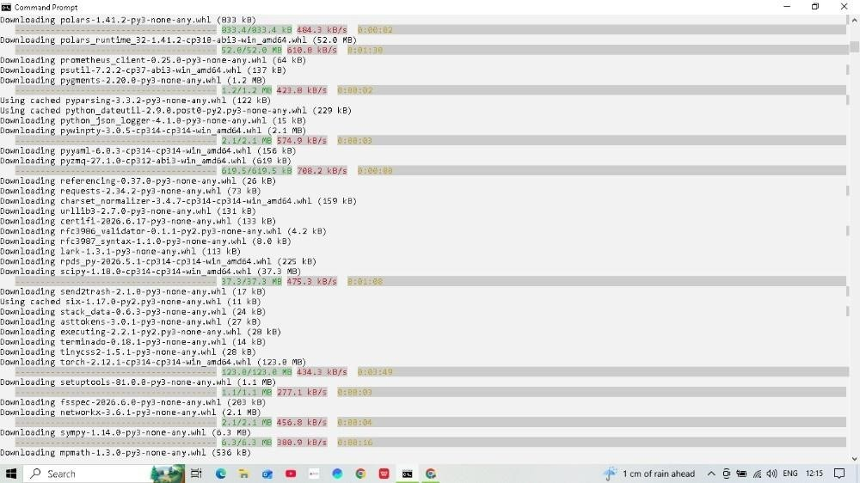

Figure 1.2: Downloading downstream analytics extensions and deep learning framework binaries (PyTorch)
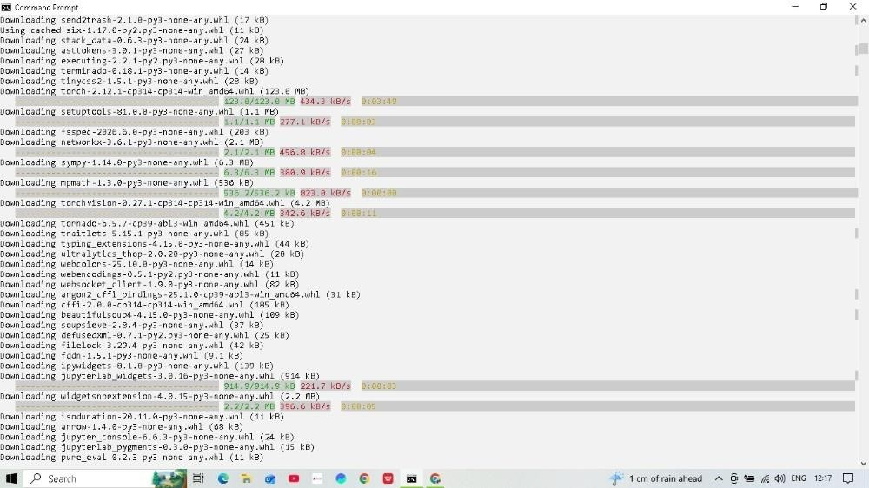
Figure 1.3: Concluding library validation pipeline logs

Verification of Installed Dependencies

System environments and package versions verification checks via CLI utilities:

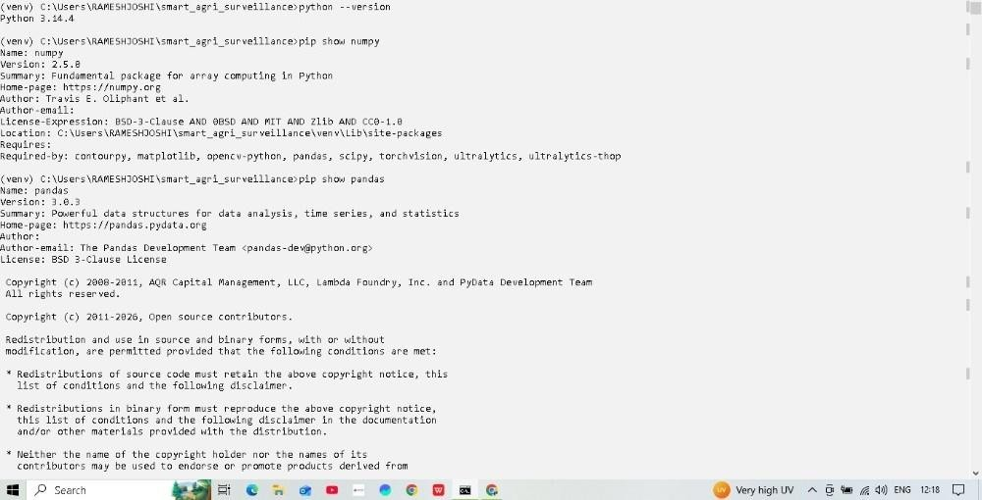

Figure 2.1: Python 3.14 environment check and metadata verification for Numpy (2.5.8) and Pandas (3.0.3)
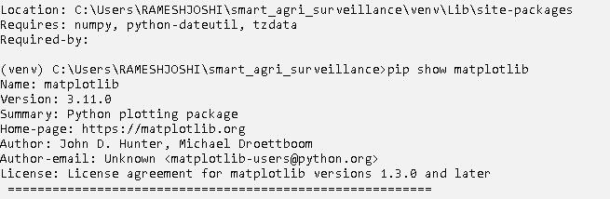

Figure 2.2: Visualization module tracking validation (Matplotlib 3.11.0)

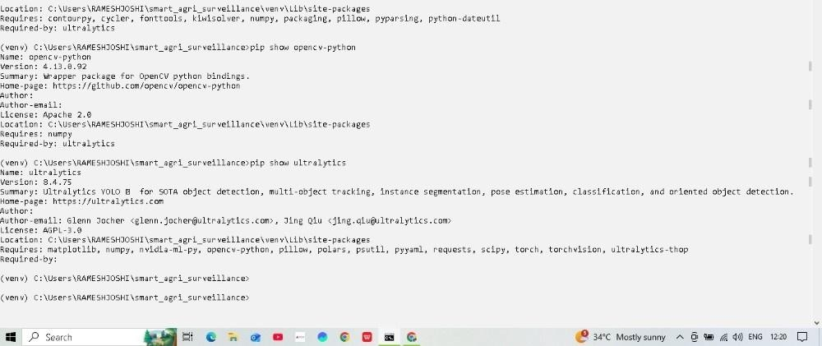

Figure 2.3: Core Computer Vision toolset validation (OpenCV 4.13.0 and Ultralytics YOLO 8.4.75)

Directory Infrastructure Architecture

Generation of sub-directories to cleanly modularize the codebase layout:
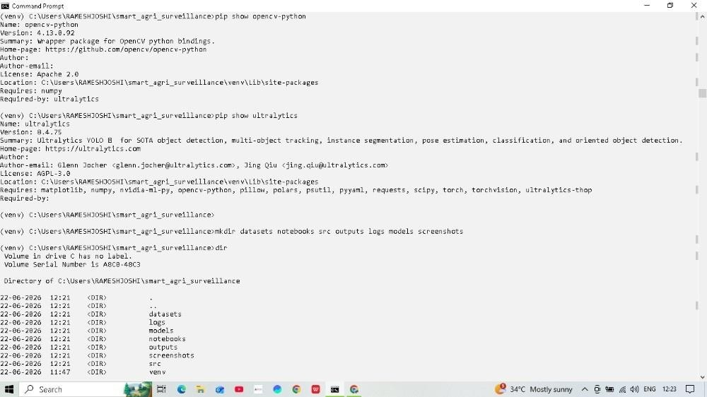

Figure 3.1: Structure directory creation (datasets, notebooks, src, outputs, logs, models, screenshots)

Core Execution Verification

Sanity checking the framework's runtime initialization compatibility:

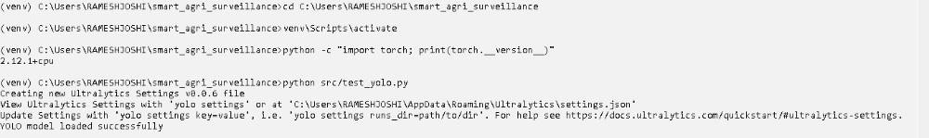

Figure 4.1: Compilation test displaying successful verification of Torch (2.12.1+cpu) and YOLO model loading sequence

Jupyter Notebook Working

This document details the initialization of the local notebook server and verifies library execution inside a live interactive environment.

Notebook Server Initialization

The Jupyter server loop successfully established communication interfaces and bound the notebook service to the local loopback addresses:
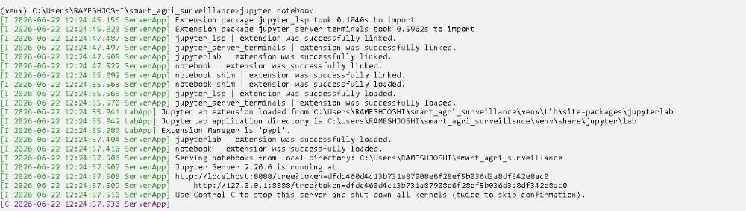

Figure 1.1: Local Jupyter Server startup log sequence via command-line runtime

Live Code Execution Verification

Verification tests executed directly within an active notebook instance confirm valid runtime environments and correct version mappings across core workspace modules:

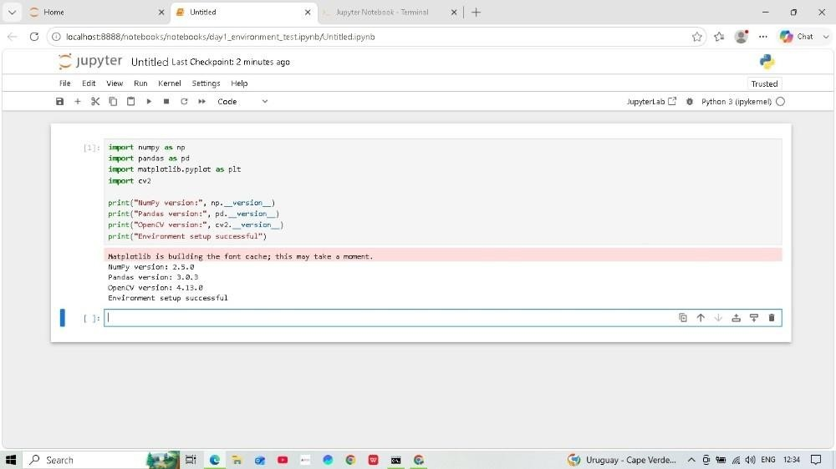

Figure 2.1: Evaluation checkpoint verification for core vision and data dependencies

Workspace Execution Checkpoints

  - Server Loop Binding: The backend infrastructure initialized correctly on
using standard token security routing.
http://localhost:8888/

Package Execution Validated:
    - version successfully resolved to .
NumPy
2.5.0
    - version successfully resolved to .
Pandas
3.0.3
    - computer vision toolkit correctly targeted at .
OpenCV (cv2)
4.13.0
  - Verification Metric: Final environment verification print statements return
"Environment setup
.
successful"

yolo test output
